Arabic OCR using a Hybrid Deep Learning Model

Abstract
Arabic writing system has many characteristics that make the recognition of Arabic text in images a challenging task. Deep Learning (DL) methods for solving classification problems have been achieving break troughs in numerous domains including those that involve image processing and sequence modelling. In this work, we examine a model for recognizing printed text in Arabic words images. The model employs a hybrid DL network that can recognize Arabic text printed in various printing styles including the printing styles that mimic Arabic hand written script. Further, the model operates in an end-to-end manner that does not require characters segmentation. The model was examined on a synthetic custom dataset comprised of over (2) million word samples that were printed using (18) different fonts styles. The model achieved high accuracy results both in terms of characters recognition accuracy (98.76%) and word recognition accuracy (90.22%); it also achieved good character recognition accuracy (85.15%) when it was examined on external dataset i.e. (APTI dataset) using a new font type.

Introduction
Optical Character Recognition (OCR) is the process of recognizing text in images and it is considered as an important process that has many uses in domains that require recognizing text in images. OCR can be categorized under two main folds, online OCR and offline OCR. Online OCR involves recognizing text in real time as it is written e.g. digital stylus writing on mobile phone screen, while offline OCR involves the recognition of text found in scanned document including documents archives as well as the mass digitalization of different printed application forms. In addition, OCR addresses two main categories of text, machine printed text and handwritten one. Recognizing handwritten text is considered more challenging because of the high variance in the hand written script and the diverse writing styles of individuals.
Recognizing Arabic hand written has additional challenges. Arabic writing system has a high cursive nature for the written script, and the connectivity between characters in words increase the challenge for identifying character boundaries. Further, the scarcity of labelled datasets for Arabic language increases the challenges in developing new solutions that depend on supervised learning models.
In this work, we examine a model that can recognize various Arabic printing styles using a DL based model. DL is a machine-learning branch that employs Deep Neural Networks (DNN) for solving various computational problems e.g. classification, regression, reinforcement learning. Neural Networks (NN) in general and DNNs in specific excel in learning and extracting features from large datasets and then classify unseen samples based on learnt weights. For that purpose, we utilize DL to examine a model that can recognize Arabic text in an end-to-end manner without the need for characters segmentation. The model is comprised of a Convolution Neural Network (CNN) and a Bi-Directional Recurrent Neural Network (RNN). Although it can be considered as a moderate in terms of its complexity i.e. number of parameters and hyper-parameters, yet it was able to achieve good results in recognizing different styles of Arabic printed text.
A custom synthetic dataset was prepared to examine the model. This dataset was generated using (18) different fonts which were collected from online sources. The selected fonts were chosen because they exhibit high cursive nature that mimics Arabic hand written styles. The dataset text samples was generated from Arabic Wikipedia Dump and it contains over (2 million) labeled samples.
Several experiments were performed using different number of samples and different printing styles. The proposed model achieved good results in in terms of characters recognition accuracy and words recognition accuracy. Nevertheless, the model performance degraded when it was tested on new printing styles or noisy images. Resolving such issues is possible through additional measures whether these are related to the model’s complexity or the usage of other techniques e.g. language models, image preprocessing…etc.
The reaming of the paper is organized as follows; in section ‎3 we discuss some of the related recent work. Section ‎4 discusses some of the challenges related to Arabic text recognition. Section ‎7 presents the proposed model in detail. Section ‎0 presents the experiments that we performed and the results that were achieved, and finally in section ‎8 we present the conclusion of this work.

Related Work
OCR has been an active area of research since the emergence of computing [1]. A major progress in the field has been achieved introduction of Graph Transformer Networks (GTN) paradigm by [2]. The main argument of that work was that better pattern recognition systems could be achieved by relying on systems that learn features automatically with less reliance on manually prepared heuristics. Numerous efforts employed the findings of [2] and several achievements where recorded ([3]–[5]).
Similar to other languages, Arabic text recognition from images was influenced by the progress that was achieved by DL models. More recently, [6] presented a DL based model for recognizing Arabic text using CNNs. The domain of that model was the recognition of single Arabic characters i.e. isolated mode. The model was examined on AIA9k [7] and AHCD [8] datasets and achieved accuracy levels of 94.8% and 97.6% on the examined datasets.

Challenges related to Arabic Language OCR
Arabic writing system is used by different natural languages including Arabic, Kurdish, Pashto, Persian, Sindhi, Uighur and Urdu. Its base alphabet is comprised of (28) characters shown in Table 1 below. The alphabets are written from right-to-left while the numbers are written from left-to-right. Natural languages that use Arabic writing system extend the base alphabet with additional symbols e.g. diacritics to better adapt the requirements of the designated spoken language. In this work, we focus on the base Arabic alphabet.
A main challenge of Arabic writing system is that it has cursive writing style. Characters in Arabic script, whether handwritten, typed or printed are connected in words and they might overlap in the same boundary. In addition, various Arabic characters share the same main shape (e.g. ba, ta, tha shown in Table 1 below), but they differ by adding a number of dots to that character. Further, the shape/glyph of Arabic characters might change according to its position in context where some characters can appear in the beginning, middle, end of a word, or appear in isolated model.
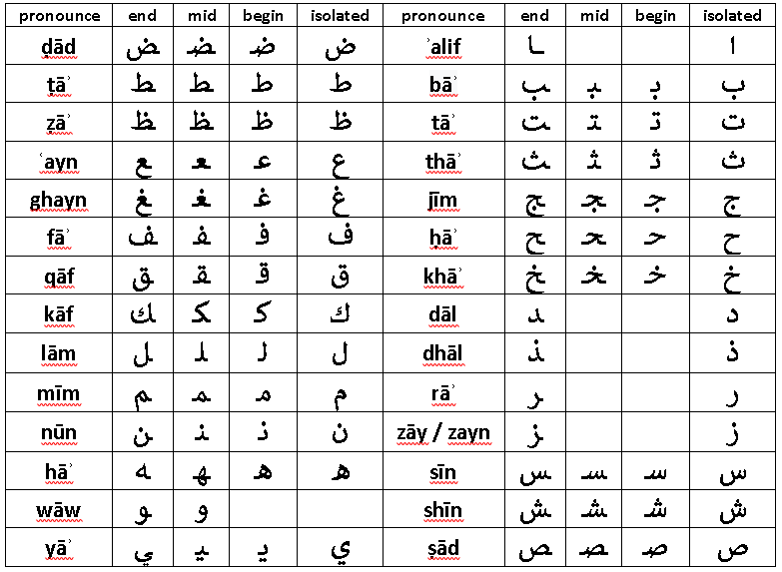
Table 1 Arabic base alphabet
All these characteristics make the recognition of Arabic text a challenging task especially for models that depend on segmenting word characters prior to the recognition process [9]. The model we present operates in an end-to-end manner without the need for character segmentation, which facilitates the recognition process.

The Custom Dataset
A custom dataset was prepared to examine the model performance. The purpose of that dataset was to provide sufficient number of labelled samples that can enable training a DL based model. Further, the images in that dataset were formatted using various fonts that exhibit highly cursive nature relatively similar to hand writing styles. Table 1 below shows (18) different fonts that are supported by the dataset.
Sample | Font Type
التعرف على النصوص العربية باستخدام تقنيات التعلم الآلي. | - ae_Nice
التعرف على النصوص العربية باستخدام تقنيات التعلم الآلي. | - Aref_Menna
التعرف على النصوص العربية باستخدام تقنيات التعلم الآلي. | - bader_lamsat
التعرف على النصوص العربية باستخدام تقنيات التعلم الآلي. | - Basim Marah Beh Light
التعرف على النصوص العربية باستخدام تقنيات التعلم الآلي. | - B Cheshmeh
التعرف على النصوص العربية باستخدام تقنيات التعلم الآلي. | - B Paatch
التعرف على النصوص العربية باستخدام تقنيات التعلم الآلي. | - BSetareh
التعرف على النصوص العربية باستخدام تقنيات التعلم الآلي. | - B Ziba
التعرف على النصوص العربية باستخدام تقنيات التعلم الآلي. | - Dast Nevis
التعرف على النصوص العربية باستخدام تقنيات التعلم الآلي. | - Dima Font
التعرف على النصوص العربية باستخدام تقنيات التعلم الآلي. | - DecoType Thuluth
التعرف على النصوص العربية باستخدام تقنيات التعلم الآلي. | - Ghalam-1
التعرف على النصوص العربية باستخدام تقنيات التعلم الآلي. | - Ghalam-2
التعرف على النصوص العربية باستخدام تقنيات التعلم الآلي. | - K Kamran
التعرف على النصوص العربية باستخدام تقنيات التعلم الآلي. | - K Tabassom
التعرف على النصوص العربية باستخدام تقنيات التعلم الآلي. | - pHalls Khodkar
التعرف على النصوص العربية باستخدام تقنيات التعلم الآلي. | - Tharwat Emara Modern
التعرف على النصوص العربية باستخدام تقنيات التعلم الآلي. | - ToyorAljanah

Table 2- The selected (18) fonts
The custom dataset contains two types of samples sets. In the first sample set, the same set of words is used to generate samples for each font type supported by the dataset e.g. Arabic word “الخدمات” appear in (font A) samples as well as the sample of all the other fonts. In addition, the first dataset include minor redundant words within the same font type as it was randomly generated (no filtering) from Arabic Wikipedia Dump. The second sample set contains unique set of words (disjoint). A single word does not repeat across all the other samples. Images in the datasets are saved in their original size, which relates to the fonts type and style. The custom dataset is made available at.

Model Architecture
Operational text recognition systems implement a number of steps to recognize text in images. These tasks might include normalizing and correcting images to enhance their quality, detecting text regions within images, detecting text lines in regions, identifying words and segmenting them into characters. Different types of text recognition approaches can be applied on the prepared images to recognize text. In addition, post-processing steps might be included such as using language models to further enhance the recognition accuracy. The focus of this work is on the recognition process itself. The model we implement recognize text in images that contain single words. The model can be extended to support multi-word recognition.
A main objective of this work is to investigate the capacity to recognize multi-style printed text using a single model. This includes printing styles that exhibit high cursive nature and fonts that mimic Arabic handwriting styles. The design and implementation of our work follow the intuitions of [10]. In that work, a hybrid NN was employed to recognize text scanned historical documents. We employ the same concepts to examine the capacity of that model in recognizing different styles of Arabic printed text.
The model we present is comprised of two main components, a convolutional NN and a Recurrent NN. These two networks are stacked together in an end-to-end paradigm that can efficiently perform word-level recognition without the need for character segmentation. Figure (X) below illustrates the general architecture of the model.

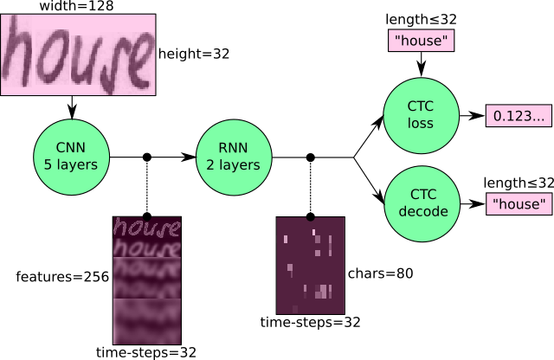
Will be changed
Figure 1-The general architecture of the model
CNN
CNN is a variant of neural networks that can automatically learn features representations i.e. filter, therefore spare the cumbersome manual interventions for creating features. A main limitation of conventional NN is that they lack the capacity to learn hierarchal features. If there is a shape in two different parts of an image, the NN has to learn duplicate weights for these two parts of the image. This mechanism is inefficient and it leads to complex networks with large number of parameters. CNN solve this limitation by introducing kernels, which can perform a sliding window function over the input sample. Therefore, a single kernel can detect several the several occurrences of the shape in a location invariant manner. The CNN is comprised of a number of layers with different number of kernels in each layer. The kernels of the earlier layers learn basic features e.g. edges if an image, while kernels in later layers learn more abstract features which are aggregates of earlier learnt features. With its distinguishing features, CNNs can efficiently extract features from images and it achieved numerous advances in the field of image classification and objects detection from images.
Bidirectional LSTM
Recurrent neural networks are a variant of neural networks that have a memory function. This memory enables the network to remember weights that it learnt during earlier steps of the learning process and therefore it is able to learn sequences efficiently. RNNs can perform several types of sequence modeling (one-to-many, many-to-many, many-to-one). In our model, the RNN is performing a sequence-to-sequence modelling, more specifically, it is processing a sequence of features that were extracted from an image and its maps them into a sequence of characters representations. A main limitation of the conventional RNNs is their bias to the vanishing gradient problem especially when sequences are long. An enhanced variant of conventional RNNs is the LSTM networks [11]. The LSTM is more suited for addressing the vanishing gradient problem by enforcing a constant error flow during the back propagation process. This is possible through the usage of a number of logical gates that can preserve important learnt values and dispose less relevant ones. However, this variant also has a limitation as it can only exploit historical data, which is the previous value it has seen but not the future ones. This limitation was resolved with the introduction of Bidirectional LSTM [12]. This type of network concatenate the hidden layers of two opposite LSTMs, therefore it is able to exploit previous context as well future context when resolving an output value.
CTC Loss
RNNs require the availability of pre-segmented training data to be able to map segments to their corresponding labels. This is essential because multiple segments of input might represent a single label. For example, multiple sequences of acoustic speech units might formulate a single phoneme. On the other hand, pre-segmenting training data is a cumbersome process that limits the benefits of RNNs. To solve this challenge, [13] introduced CTC loss mechanism that can enable the automatic segmentation of input samples through the learning process.
The CNN is comprised of (5) layers. Different kernel sizes are used in each layer. Table 2 below shows the details of the CNN as well as the number of its learnable parameters.
CNN
Shape | Number of Parameters | Activation | Max pooling
(5, 5, 1, 32)  (5, 5, 32, 64)  (3, 3, 64, 128)  (3, 3, 128, 128)  (3, 3, 128, 256) | 864  51328  73984  147712  295424 | RELU  RELU  RELU  RELU  RELU | (2x2)  (2x2)  (2x2)  (1x2)  (1x2)
RNN
Shape |  | Number of Parameters
(512, 1024)  (512, 1024)  (1, 1, 512, 52) |  | 525312  525312  26624
Total Parameters |  | 1645536
Table 3 – Neural Network Details

a number of gates that can forget/remember
To extract features, the CNN performs three main operations: Convolution, RELU activation and Max Pooling. The convolution process extract features from the image based on the weights that it learnt during the training process. The max pooling process is a mechanism that can select the most relevant features from that were extracted by the convolution process. The pooling layer gradually downsizes convolution outputs into reduced set of features that represent the classified objects, which is a set of characters in our model.

The recurrent learning process in the model is implemented by (2) stacked BiDrectional LSTM layers.
a matrix of size (32 x 256). This matrix represent (32) sequence frames with (256) feature in each sequence frame. Consequently, the model is able to recognize input text of size (32) characters as a maximum.
The RNN is implemented using two stacked bidirectional Long Short-Term Memory (LSTM) layers with (256) hidden nodes in each layer.
The model accepts a grayscale image input of size (128 x 32). The CNN receives the input and performs three main operations: Convolution, RELU activation and Max Pooling. The convolution process extract features from the image based on the weights that it learnt during the training process. The max pooling process selects the most important feature in the convolution layers and gradually downsizes the convolution output into a matrix of size (32 x 256). This matrix represent (32) sequence frames with (256) feature in each sequence frame. Consequently, the model is able to recognize input text of size (32) characters as a maximum.
The output of the CNN is delivered to the recurrent neural network i.e. LSTM network. The LSTM processes that input and enforce the sequence learning feature which basically resembles the process of learning a language model [14]. The output of the LSTM network is a matrix of size (32 x vocabulary size) which represent is passed to a CTC loss function that computes the scores or the label probability for each sequence frame. The loss values are back propagated to the network to adjust parameter values using Gradient Descent algorithm. The final output of the network is a matrix of size (32 sequence frames x length of characters vocabulary) that includes the characters probabilities for each time step which can be decode back to their corresponding labels.
The interesting fact about this model is that the stacking of the CNN and the RNN directs the CNN to transparently learn and extract features that exhibit sequence structure as show in Figure 2 where CNN output [0] corresponds to RNN input [0].

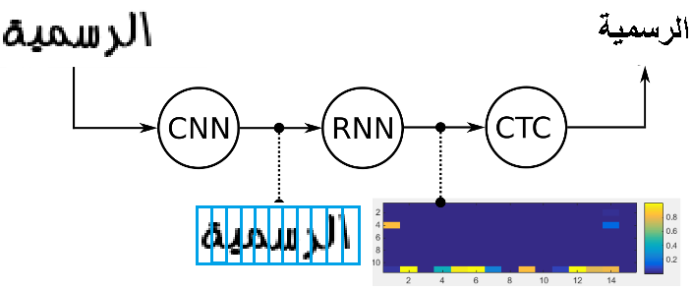
Figure 2

To examine the model, we used words samples that have (7-10) characters length. These samples were generated using the (18) selected fonts that were presented in Table 1 using bold font style and size (26) units. Since the images have variable sizes according to the text and the used font, they were resized to (128 x 32) pixels, which correspond to the model’s input. Figure 4 below shows a sample of a single word using three different fonts before and after the resizing process. The resizing process might produce a smaller version of the original image, but CNNs in concept supports location invariance for its learnt features.
Original Size
height:35; width:84 | height:41; width:88 | height:27; width:67
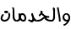 | 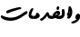
Resized Version
height:32; width:128 | height:32; width:128 | height:32; width:128
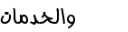 | 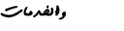 | 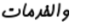
Figure 3-Images before and after resizing

Experiments and Results
The model was examined using two different platforms, Google Colab environment with the following specifications:
Python version: 3.4.
Tensor flow version: 1.13.1.
Hardware Accelerator: GPU.
RAM: 12.72 GB.
HDD: 64.4 GB.
To evaluate the model’s performance we used the following measures:
$$Characters Accuracy=\frac{Number of correctly identified characters}{Total number of characters}$$

$$Word Accuracy=\frac{Number of correctly identified words}{Total number of words}$$

To examine the model, we used different samples selections to represent different scenarios. Table 3 below shows the sample collections that were used to run the different experiments.
The (ae-nice) font was selected to run single font experiments as its printing style is rather formal and it contains cursive structures that clearly resemble a hand writing style. Similar, the (ae-Nice) and (K-Karman) fonts were selected to run the dual fonts experiments. Table 1 shows the fonts that were selected to run the (18) fonts experiments along with a sample text for each font type. All text samples were generated using bold font style and font size (26).
The datasets were split into (train, validate, test) segments with a ratio of (80%, 10%, 10%). In scenarios (1, 2, 3, 4) shown in Table 4 below, the (train, validate, test) included redundant words. As clarified in ‎section ‎5, this duplication is related to the method that was used to generate the samples list. In that method, the same word list was used to generate samples for each of the selected font types. Consequently, the same word might appear in different dataset segments (train, validate, test), but mainly it appears in a different font type. In scenario (18), the samples set that was selected is unique and has no cross redundancy between the (train, validate, test), any given sample word appears once in the whole dataset.
# | # of fonts | # of samples | Duplicate in samples | Dataset size
1 | 1 | 60,000 | Exist | 148MB
2 | 1 | 120,000 | Exist | 295MB
3 | 2 | 240,000 | Exist | 522MB
4 | 18 | 2,160,000 | Exist | 6350MB
5 | 18 | 450,000 | Unique words | 1300MB
Table 4-Dataset details for each test scenario
Several experiments were performed on the proposed model to examine its performance from various perspectives. Table 4 below shows a summary of the achieved results,
Initially, the model was examined on a relatively small sample set using a single font type (set 1 in Table 4) and it achieve good accuracy (97.5%, 85.18%) for words and characters respectively but it required more numbers of epochs to converge. The model was also examined using a larger dataset for the same single fonts and its performance was enhanced (99.04%, 94.29%). In general, the model achieved good results when it was used to examine single font datasets regardless of the type or the printing style of the font that was used.
To examine the model’s representation and recognition capacity using a more diverse set of samples, we examined it using two font types (sample set 2 in Table 4). Under that dataset, the model also achieved good results (99.88%, 99.2%) accuracy for words and characters respectively. Nevertheless, and although batch normalization was used after each convolution layer, the high accuracy that was achieved indicates that the model was overfitting the samples data as its ability to recognize external fonts was low.
The model was tested on an extended samples set which included samples for (18) different font types (sample set 4 in Table 4) and still it achieved high accuracy results (99.27%, 94.32%) for characters and words respectively. The initial intuition for the high accuracy results that were achieved might be related to the duplication in (train, validate, test) samples. Therefore, we retrained the model using a new and unique dataset where a sample word does not repeat in the whole dataset (sample set 5 in Table 4) above. The performance of the model demonstrated a minor decrease but it was still relatively high (98.76%, 90.22%) for such diverse set of samples over a relatively moderate RCNN model.
 |  | Validation Dataset Accuracy |  | Test Dataset Accuracy
 |  | Character | Word | Character | Word
1 | Single font model | 98.37 | 90.28 | 97.5 | 85.18
2 | Single font model – larger dataset | 99.148 | 94.66 | 99.044 | 94.29
3 | 2 fonts model | 99.93 | 99.5 | 99.88 | 99.2
4 | 18 fonts, duplicate words across fonts types | 99.38 | 94.84 | 99.27 | 94.32
5 | 18 fonts, unique words across the dataset | 98.81 | 90.53 | 98.76 | 90.22
6 | Testing model 5 on 5 character words | - | - | 98.71 | 92.4
7 | Testing model 5 on APTI dataset – new font | - | - | 85.15 | 23.7
8 | Testing model 5 with salt & pepper noise. | - | - | 82.01 | 21.48
9 | Testing model 5 with salt & pepper and speckle noise. |  |  | 77.29 | 14.18
Table 5-Performance results of the model
To further examine the recognition accuracy of the model and to measure it generalization capabilities, we examined the model using datasets settings different from the ones that was used in the (train, validate, test) process.
Initially, we examined the model using a new dataset with word length of (5 - 6) knowing that the model was trained on a dataset of (7 – 10). Under that scenario, the model also achieved high accuracy (98.71%, 92.4%). This indicates that the model was performing suitable generalization over the trained samples, as it was able to accurately extract and recognize characters features regardless of the words length.
To further investigate the model’s generalization capability, we examined it on a sample set from the synthetic (APTI) dataset [15]. We selected a single font type to run the experiment (Arabic Typesetting). Although the model was not trained or fine-tuned on that dataset, it was able to achieve good accuracy results in recognizing characters (85.15%). However, the performance of the model degraded in the overall words accuracy (23.7%). This observation is justified as the words accuracy is highly dependent on the characters recognition accuracy and a single character misclassification in a relative long word (7 – 10 characters) shall fail the recognition process for the word.
We also examined the model performance after introducing noise to the test samples. For that purpose, we introduced Salt & Pepper (S&P) and Speckle noise transformations to the test images. Figure 4 below shows a sample word before and after introducing noise adjustments.
Original | Salt and Pepper | Salt and Pepper + Speckle
Figure 4 - Samples images with noise
Similar to the (APTI) scenario, the model achieved acceptable accuracy in recognizing characters () for (S&P) and (S&P + Speckle) noise respectively, but the word level accuracy was severely degraded.
Figure 4 below summarizes the model’s performance under the different scenarios.

Figure 5-Model performance under difference scenarios
The examination process demonstrates that the model can produce high accuracy when the model is trained on specific set of fonts while this set of fonts can be extended using a or a larger or more complex model. The accuracy results of the test scenarios related to noise can be enhanced by using different image normalization techniques, which can reduce the noise levels in the tested image.
Nevertheless, this implies that additional measures have to be investigated in order to enhance the performance of the model. Such measures might include the introduction of additional preprocessing steps to normalize the images and decrease the variance in characters representations; this also includes the extending of the model size (parameters) to extend its learning capacity as the model might be under fitting the data. In addition, additional methods might be investigated i.e. Attention Mechanism, in order to enrich the representation capacity of the learned features.

Conclusion

ResizeNoStrectch | ResizeWithStretchWithoutAspectRatio | ResizeWithStretchAndAspectRatio
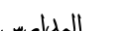 | 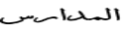 | 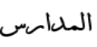

The model is based on employing a combination
Intricacies of the script and the absence of ample annotated data further act as adversaries to this task.
e demonstrate the effectiveness of an end-to-end trainable hybrid CNN-RNN architecture in recognizing Urdu text from printed documents, typically known as Urdu OCR. The solution proposed is not bounded by any language specific lexicon with the model following a segmentation-free, sequence-tosequence transcription approach.
Furthermore, past and future contexts modelled by bidirectional recurrent layers aids the transcription. We outperform previous state-of-theart techniques on the synthetic UPTI dataset. Additionally, we publish a new dataset curated by scanning printed Urdu publications in various writing styles and fonts, annotated at the line level. We also provide benchmark results of our model on this dataset.
In this paper, we present a model for Arabic Optical Character Recognition using deep learning that can be used for recognizing different types of Arabic texthand written text.
The model is based on a neural network that has three main components for processing, a Convolution Neural Network (CNN) that process input and a Recurrent Neural Network (RNN)
Introduction
The scripts for Urdu use 45 characters as their basic building blocks. Of these, 5 characters appear only in isolation, 10 appear only at the beginning or at the end of a word and 1 character is bound to occupy only middle positions. The other 27 characters are free to occur in isolation or at the beginning, middle or end of a word. Additionally, there are 26 punctuation marks, 8 honorific marks and 10
Also, the position of a character in a word (at the beginning, middle or end) changes the shape of the glyph used to represent the character completely.
http://cdn.iiit.ac.in/cdn/cvit.iiit.ac.in/images/ConferencePapers/2017/ACPR_Camera_Ready___Urdu_OCR__Final_.pdf
Related Word
Recognizing cursive scripts has been an active field of research. Initial work in this domain was by [4], who presented an OCR solution for languages with large character-sets (like Japanese, Chinese, etc.).
http://cdn.iiit.ac.in/cdn/cvit.iiit.ac.in/images/ConferencePapers/2017/ACPR_Camera_Ready___Urdu_OCR__Final_.pdf

Segmentation free methods have come into light recently. These methods are generally based on Hidden Markov Models (HMM) or Recurrent Neural Networks (RNN)
A novel approach combining the robust convolutional features and transcription abilities of RNNs was introduced for English scene text by [19].
The unconstrained hybrid CNN-RNN architecture can be trained in an end-toend fashion using the CTC loss. By providing an unconstrained solution, we mean that our model is not bounded by any language-lexicon and any possible combination of the script’s character-set can be recognized.
Related Work
The problem of approaching OCR for Arabic script approaches by several research. Some of the a
Proposed Model
BLSTM Architecture RNNs are an optimal choice for our unconstrained endto-end system as they have a strong capability of capturing contextual information within a sequence. Additionally, RNNs are capable of handling variable length sequences. Since the number of parameters in a RNN is independent of the length of the sequence, we can simply unroll the network as many times as the number of time-steps in the input sequence. This helps us perform unconstrained recognition, where the predicted output can be any sequence of labels from the entire label set (192 unique characters/glyphs and punctuation marks in our case).
Traditional RNN units (vanilla RNNs) face the problem of vanishing gradients [20] and hence (LSTM) units are used, which were specifically designed to address the vanishing-gradients problem [21], [18].
. In a text recognition problem, contexts from both directions (left-toright and right-to-left) are useful and complementary to each other in performing correct transcription. Therefore, a combined forward and backward oriented LSTM is used to create a bi-directional LSTM unit. Multiple such bi-directional LSTM layers can be stacked to make the network deeper and gain higher levels of abstractions over the image-sequences as shown in [22].
The transcription layer at the top of the network is used to translate the predictions generated by the recurrent layers into label sequences for the target language. The CTC layer’s conditional probability is used in the objective function as shown in [13]. This objective function calculates a cost value directly from an image and its ground truth label sequence, eliminating the need to manually label all the individual components in a sequence
CTC
https://towardsdatascience.com/intuitively-understanding-connectionist-temporal-classification-3797e43a86c
Discuss the design of the network, use medium.
The depth of the network and the size of different layers to be used depends greatly on the dataset and the problem domain.
Finding the suitable model is challenging, requires experimentation.
So, in our case we tested different architectures by varying these parameters and presented results of the architecture producing the highest accuracy on the test data set. The result of the tests are summarized on the Experimental setting and results section.
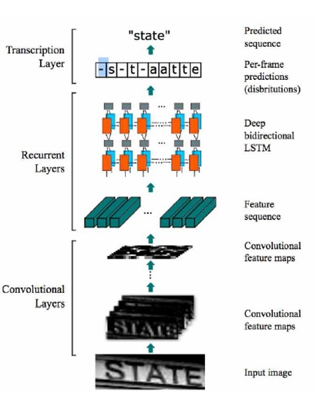 https://github.com/qjadud1994/CRNN-Keras
About CNNs
CNNs can address positional variation problems in images, this can serve OCR applications as the characters in text string can have numerous shapes according to the used font in machine printed texts as well as the different right styles of individuals regarding handwritten text.
Deep Neural networks consist of multiple nonlinear hidden layers and so the number of connections and trainable parameters are very large. Besides being very hard to train, such networks also require a very large set of examples to prevent overfitting. One class of Deep Neural Network with comparatively smaller set of parameters and easier to train is Convolutional Neural Network (CNN)[7].The ability of CNN to correctly model the input dataset can be varied by changing the number of hidden layers and the trainable parameters in each layer and they also make correct assumption on the nature of images[8]. Like a standard feed forward network, they can model complex non-linear relationship between input and output. But CNN have fewer trainable parameters than a fully connected feed-forward network of same depth. CNNs introduce the concept of local receptive field, weight replication and temporal subsampling[9] which provide some degree of shift and distortion invariance. CNNs for image processing generally are formed of many convolution and sub-sampling layers between input and output layer. These layers are followed by fully connected layers thereby generating distinctive representation of the input data. Beside image recognition, CNNs have also been used for speech recognition[10][11].
Deep Learning Based Large Scale Handwritten Devanagari Character Recognition

Convolutional Layer
Extracts features through CNN Layer (VGGNet, ResNet ...).

Recurrent Layer
Splits the features into a certain size and inserts them into the input of the Bidirectional LSTM or GRU.

Transcription Layer
Conversion of Feature-specific predictions to Label using CTC (Connectionist Temporal Classification).
https://github.com/qjadud1994/CRNN-Keras/blob/master/README.md

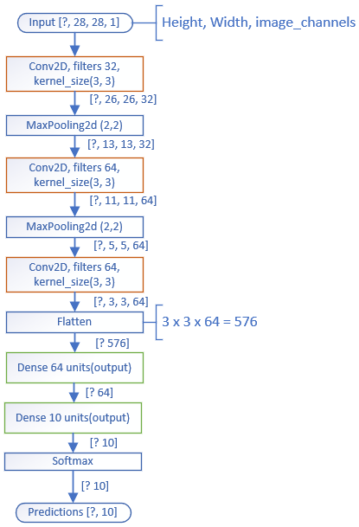

V. EXPERIMENTAL SETTINGS AND RESULT
We tested the dataset with different architectures by varying depth, width and number of parameters of network. The results of two of those experiments are presented in the coming sections. The first model is very wide and deep and consists of a large number of parameters. It will be referred to as “model A” in the coming section. It consists of three convolution layers and one fully connected layer. The sequence of the layers in model A is shown in Fig 3., where C is a convolution layer, R is a Rectified Linear Unit Layer, N is Normalization layer implementing Local Response Normalization, P is pooling layer implementing max pooling, D is the Dropout layer, FC is the Fully Connected Layer, A is accuracy layer for test set and SL is the Softmax Loss layer that computes multinomial logistic loss of the softmax of its input. The second model is derived from the lenet family. It has a shallower architecture and consists of fewer number of parameters than model A .It will be referred to as “model B” in the coming section. It consists of two convolutional layers followed by two fully connected layers. The sequences of layers in model B is shown in Fig 4. where each notation holds similar meaning as discussed for model A.
In all cases, Convolution is implemented with overlapping Filter(Kernel) of Size 5*5 and stride 1 on both direction. Pooling is implemented with a non-overlapping Filter of size 2*2 and stride 2 on both directions. Local response Normalization is achieved by dividing each input value by the following expression
(1+ ( α /n)Σixi2)β (1)
 
, where n is the size of each local region, and the sum is taken over the region centered at that value. The value of α-parameter used is 0.001 and β-parameter is 0.75.
Our deep neural network was trained on the DHCD as a multi-class classification problem. For both the models, the standard back-propagation on feed-forward net is implemented by stochastic gradient descent (SGD) with momentum of 0.9. The mini-batch size is 200 and the network was trained for 50 epochs. The base learning rate was initialized for all trainable parameters at 0.005 for Model A and 0.001 for Model B. The learning rate was updated by an inverse function using the following relation
LearningRate = BLR × (1 + γ × iterations)-power (2)
, where BLR is the Base Learning Rate and iterations is the number of iterations completed. The value of γ was set to 0.0001 and power was set to 0.75.
The result of training for 50 epoch is presented in Fig. 5. Test Accuracy remained nearly constant after 50 epochs. For Model A, Extended Dataset showed superior result in Test Accuracy. So, increasing number of training sample is effective to increase performance of wide and deep network with large bank of parameters. The highest testing accuracy obtained for Model A is 0.98471. For model B, addition of dropout showed better improvement in Test accuracy. However, extending dataset also resulted in slight improvement in Test accuracy. The highest value of Testing Accuracy obtained for this model is 0.982681.

Challenges of Arabic Language OCR
One problem with recognizing the Arabic alphabet is that many characters have similar shapes but with varying locations of dots relative to the main part of the character. Figure x-a shows the Arabic alphabet in isolated mode, as can be seen by the figure, the letter (ج – ح – خ) have similar shapes while only place or changing a dot into the alphabet. It is noteworthy that handwritten characters are more challenging, since human writers tend to combine dots and use dashes instead or change the shape of characters as can be seen in Figure 2, which shows 48 handwritten samples of the same letter "Ayn" that were used in previous work. Moreover, the Arabic alphabet is widely used by many people from different countries including all Arab countries in addition to being used in the Persian, Urdu and Pashto languages.[6]

Experiments and Results
Info | Experiment 1 | Experiment 2 | Experiment 3 | Experiment 4
Experiment Number | 1
Number of words | 100000
Words length | 7-10
Number of fonts | 1
Font name | ae_Nice
Font size | 26
Bold | True
Image size (w, h) | 128, 32
Number of convolution layers | 5
Samples per epoch | 25000
Batch size | 50
RNN Hidden Units | 256
Training/Validation | 95%
CTC Loss | 0.029822256
Epoch 4 Validation Result  Correct characters | 96.84%
Epoch 4 Validation Result  Correct Words | 80.28%
Epoch 5 Validation Result  Correct characters | 97.867%
Epoch 5 Validation Result  Correct Words | 85.8%
Epoch 7 Validation Result  Correct characters | 98.2%
Epoch 7 Validation Result  Correct Words | 88.4%
Epoch 9 Validation Result  Correct characters | 98.75
Epoch 7 Validation Result  Correct Words | 91.52
Epoch 11 Validation Result  Correct characters | 98.92
Epoch 11 Validation Result  Correct Words | 92.6
Epoch 12 Validation Result  Correct characters | 99.3
Epoch 12 Validation Result  Correct Words | 95.02
Execution time | ~5 hours
 | Laptop

Future Work
Conclusion

pronounce | end | mid | begin | isolated | pronounce | end | mid | begin | isolated
ḍād | ـض | ـضـ | ضـ | ض | ʾalif | ـــــا |  |  | ا
ṭāʾ | ـط | ـطـ | طـ | ط | bāʾ | ـب | ـبـ | بـ | ب
ẓāʾ | ـظ | ـظـ | ظـ | ظ | tāʾ | ـت | ـتـ | تـ | ت
ʿayn | ـع | ـعـ | عـ | ع | thāʾ | ـث | ـثـ | ثـ | ث
ghayn | ـغ | ـغـ | غـ | غ | jīm | ـج | ـجـ | جـ | ج
fāʾ | ـف | ـفـ | فـ | ف | ḥāʾ | ـح | ـحـ | حـ | ح
qāf | ـق | ـقـ | قـ | ق | khāʾ | ـخ | ـخـ | خـ | خ
kāf | ـك | ـكـ | كـ | ك | dāl | ـد |  |  | د
lām | ـل | ـلـ | لـ | ل | dhāl | ـذ |  |  | ذ
mīm | ـم | ـمـ | مـ | م | rāʾ | ـر |  |  | ر
nūn | ـن | ـنـ | نـ | ن | zāy / zayn | ـز |  |  | ز
hāʾ | ـه | ـهـ | هـ | ه | sīn | ـس | ـسـ | سـ | س
wāw | ـو | و |  |  | shīn | ـش | ـشـ | شـ | ش
yāʾ | ـي | ـيـ | يـ | ي | ṣād | ـص | ـصـ | صـ | ص

The historical backgrounds for text recognition from images can be traced back to early and mid 20th century when the objective of these early works was related to presenting solutions that can assist the visual handicapped individuals in reading printed text as well as the classification of postal mail.

https://dataset

